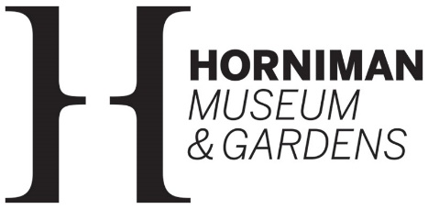

Communications Volunteer (Volunteering Team)
Role description

The Horniman Museum and Gardens has been open since 1901 when the tea trader and philanthropist, Frederick Horniman, first opened his house and extraordinary collection of objects to the local community. Since then, the Horniman has grown significantly and includes internationally important collections of Anthropology and musical instruments, as well as an Aquarium, a Butterfly House and Natural History Gallery – all surrounded by 16 acres of beautiful Gardens.

Main purpose
The Horniman hosts around 200 volunteers who make a fantastic contribution to every aspect of museum and garden life. This role, based in our small, friendly volunteering team, will focus on showcasing their talents as well as involvement in work to improve our volunteers’ experience. You will have lots of scope to develop the role, be creative and get hands on with day to day activity.

Tasks could include:

- Develop short videos to showcase volunteers’ activities across the museum
- Creating digital content with web team guidance to promote our volunteers and volunteering opportunities e.g. via Instagram.
- Producing content for our monthly newsletter for our volunteers
- Helping deliver celebratory events for volunteers and events and material to showcase their contribution
- Researching how other museums and gardens involve, support and celebrate volunteers and develop recommendations
- Contributing to work to improve the volunteer experience. This could include conducting a survey or helping facilitate a focus group
- Providing hands on help to volunteering activity such as our volunteer led family craft activity and ‘Engage’ programme which enables the public to handle objects on the museum collection
- Supporting day to day volunteer management with administrative tasks

Level of commitment
This is a regular, ongoing role, volunteering once a week, with the possibility to increase to twice a week. We are looking for a minimum 6-month commitment.

Due to the nature of the role, volunteers will be asked to provide an enhanced DBS (police check) certificate. The museum will pay and arrange for this.

This role would suit someone who:
- Is a great communicator, both verbally and in writing
- Is creative and has some experience or is willing to get some experience in developing short videos.
- Is digitally competent.
- Is able to engage with a wide variety of people of all backgrounds, abilities and ages
- Is able to work independently with minimum supervision

The museum offers volunteers:
- Opportunities for personal development in a supportive learning environment
- Reimbursement of travel expenses within Greater London
- Special events for volunteers including behind-the-scenes talks and socials.
- A 20% discount at the café and the shop
- Free entry to paid areas of the museum

Minimum age requirement:
Due to the nature of the role and level of support available, this role is only open applicants aged 18 and over.

To apply
Please ask for an application form by emailing: volunteering@horniman.ac.uk

If you have any questions about the role or would like to discuss any access requirements, contact Volunteering Manager, Karen Sheldon ksheldon@horniman.ac.uk

Closing date for applications: 24th March
Interviews: 2nd April

Date of approval by Volunteering Manager: 06.03.2024

